**FULL SUBTRACTOR:**

**EXP NO:24**

**AIM:**To design and implement the full subtractor using the Logisim simulator.

**APPARATUS:** logicism

**PROCEDURE:**

1)      Pick and place the necessary gates.   
2)      Insert 3 inputs into the canvas.   
3)      Connect the inputs to the XOR gate, AND gate and OR gate.  
4)      Insert 2 outputs into the canvas.  
5)      Make the connections using the connecting wires.  
6)      Verify the truth table.

**TRUTH TABLE:**

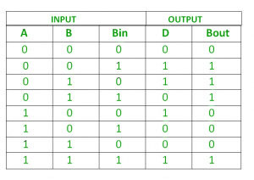

Diff= (A ⊕ B) ⊕ 'Borrowin'  
Borrow=A’. B + (A ⊕ B)'

**OUTPUT:**

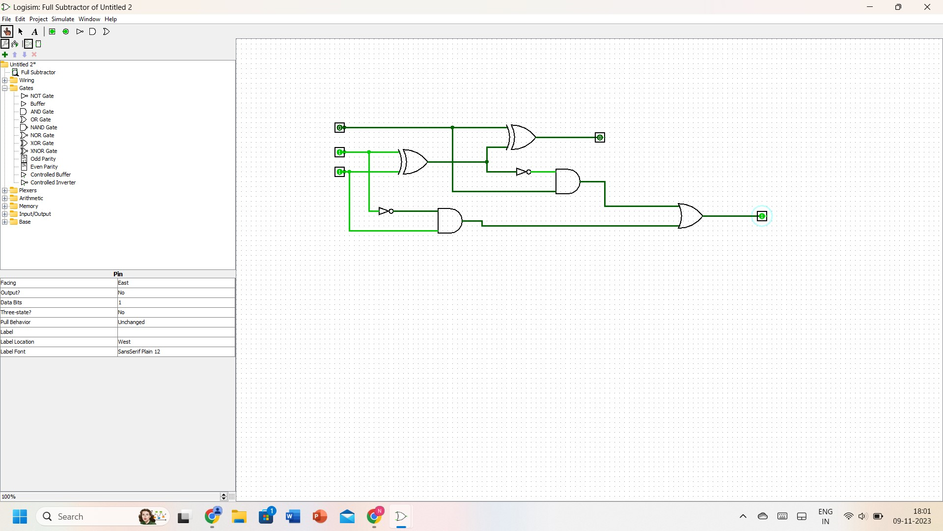

**RESULT:** Thus full subtractor has been designed and implemented successfully using a Logisim simulator.